Title in English
(title may be maximum two lines)
…
First Author,¹ Second Author,² ..., Last Author¹
¹First author's affiliation, City, Country
²Second author's affiliation, City, Country
...
E-mail: Presenting author's e-mail address
…
Abstracts should be written in English and should be at least 200 words, but not exceeding one A4 page, including figures and references, with margins 2.5 cm all around. Use font type Calibri, with single spaced lines. The Title in English should be formatted 14 pt bold, centered, sentence capitalization and it can span in maximum two lines (followed by a blank line, 12 pt). Author names should be separated by commas and marked with superscript when necessary to distinguish authors from different affiliations. The name of presenting author should be underlined. Authors’ affiliations (11 pt, italic, centered) are written in separate lines when there is more than one affiliation, and last affiliation is followed by a blank line (11 pt). The e-mail address (11 pt, centered) of the presenting author should be given (followed by one blank line, 12 pt).
Abstract text (12 pt) is justified at both sides. First paragraph is not indented; only following paragraphs, if any, are indented. The body of the abstract should be followed by a blank line (12 pt). References should be indicated in the text in square brackets [1–3] and listed at the end of the abstract (11 pt) [1–3]. Figures, if any, should be placed preceding the reference list.

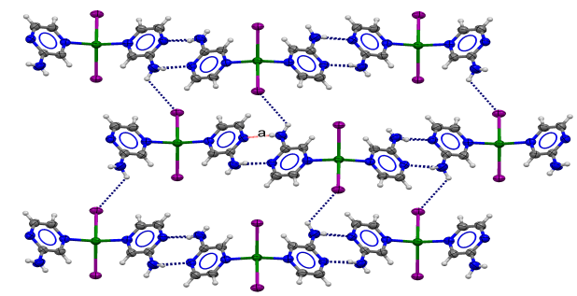

Figure 1: Figure caption (font type Calibri, 10 pt).

References
[1] A.A. Author, B.B. Author and C.C. Author, Journal Title volume (year) first page–last page.
[2] A.A. Author, B.B. Author and C.C. Author, Book Title, Publisher, city, year of publication.
[3] A.A. Author, B.B. Author and C.C. Author, Chapter Title, in: X.X. Editor1 and Y.Y. Editor2 Book Title, Eds., Publisher, year, city; pp: first page–last page.

